Extrapolation of fertilizer recommendations for major crops in West Africa, a pilot project for proof of concept

JGB Leenaars and M Ruiperez Gonzalez, ISRIC – World Soil Information, 2017

Draft report 2017 06 19

ToC
Summary

1. Introduction

1.1. Objective
General: Produce proof of concept for upscaling of site-specific fertilizer recommendations for major crops in the Ecowas region
Specific: Extrapolate NPK recommendations from limited point data for pilot crops (sorghum, maize and irrigated rice and possibly pearl millet and cassava) to maps for pilot countries (Benin, Burkina Faso and Ghana).

The deliverables are listed in the Terms of Reference as given in annex 1.

2. Methods and materials

The overall approach, including specific activities, is formulated in the Terms of Reference as given in annex 1. Basically, the approach implies the compilation and use of NPK recommendations, geo-referenced at point locations and as formulated by the various NARs from fertilizer trial data, which are modelled relative to spatial covariate data and extrapolated in the form of maps. We adopted a tiered approach to do the modelling and extrapolation, with the methods and materials within each Tier depending on the availability, and the timeliness of the availability, of either fertilizer recommendations and/or fertilizer trial data at point locations or FeRWAM data (Fertilizer Recommendations for West Africa Map) following suggestions of the scientific and technical committee.

- Tier 1 was developed and implemented on the basis of yet unavailable data and unavailable recommendations. Crop- and site-specific NPK recommendations were calculated and mapped using a tailored made version of the QUEFTS model with input data which were derived from publicly available maps of soil properties (ISRIC SoilGrids) and attainable yields (FAO GAEZ) and crop parameters derived from literature. The basis of calculating the NPK recommendations was the nutrient gap between crop nutrient requirements (demand) at target yield and soil nutrient availability (supply).
- Tier 2 makes use of the georeferenced fertilizer trial data which were compiled under a common standard and made available. The data were used where possible to adjust the crop parameters needed for QUEFTS. With the adjusted parameters and using QUEFTS we calculated the crop yields for each trial in response to the NPK treatments and compared the calculations with the measurements. Following this validation we applied QUEFTS onto the gridded input maps and calculated gridded output maps of crop- and site-specific NPK recommendations as well as of the associated yields when fertilized accordingly and when unfertilized.
- Tier 3 makes use of the georeferenced fertilizer recommendations which were reported from the trial data and made available. These reported recommendations were used where possible to validate the recommendations as calculated in Tier 2. Moreover, these fertilizer recommendations, as reported from the trials, were modelled using machine learning and extrapolated. The resulting maps of the extrapolated fertilizer recommendations were validated and inputted to QUEFTS to calculate and map the associated yields when fertilized.

For Tier 2 and 3, the site-specific results per crop were aggregated according to globally coherent agro-ecological zones per country. These aggregated results can be compared with the recommendations compiled in FeRWAM.

After a validation meeting with the STC, few parameters have been adjusted and Tiers 2 and 3 have been produced again.

2.1. Compile fertilizer recommendations to be extrapolated

Required to extrapolate fertilizer recommendations are data on fertilizer recommendations which are georeferenced and available. While these data were compiled, preparations were made to enable the production of maps of fertilizer recommendations either with (Tier 3) or without (Tier 2 & 1) using those data on fertilizer recommendations, therewith anticipating the possibility of untimely availability of the data or other possible bottlenecks for making use of the data. Additionally, the preparations enabled the production of maps of fertilizer recommendations either with (Tier 2) or without (Tier 1) using fertilizer trial data.

2.1.1. Compile georeferenced site and crop-specific fertilizer recommendations (at xy-point locations) and related fertilizer trial data, as made readily available by IFDC (activity 1A & deliverable)

Fertilizer trial data were georeferenced and compiled for each of the three countries and interpreted to formulate derived fertilizer recommendations. For this purpose, three consultants were involved to prepare and compile data from various datasets into a common template and to interpret and formulate fertilizer recommendations from these trial data. The data were made available and the applicability of the data was reviewed. Added to these data were trial data compiled by the OFRA project.

The template was prepared by ISRIC as a suggestion to facilitate the compilation under a common standard, including guidelines for standardisation (e.g. each trial, repetition and treatment requires a consistent identifier and a consistent reference to the data source (lineage), metadata to describe the experimental conditions (crop, crop variety, location, year, type of trial (omission trial, validation trial, on farm trial, on station trial, etc.), coordinates to georeference the location expressed in decimal degrees, information about the management applied including the use of additional fertilizers (manure, micro-nutrients, etc.), soil data using adequate and explicit units of expression (e.g. g/kg, g/100g), the fertilizer treatments expressed in elemental form (kg/ha of N, P and K instead of e.g. NO3, P2O5, K2O), the treatments including the control treatments (0,0,0 kg/ha), yield and biomass dry matter (instead of yield and straw fresh matter), elemental N, P and K contents in g/100g tissue dry matter) and last but not least the recommendation interpreted from the trial together with the associated measured yield.

2.1.2. Review applicability of the compiled fertilizer recommendations, and related fertilizer trial data (activity 1B)

The applicability of the data, for the purposes of this study, was reviewed. The purposes include:
- Parameterization of the QUEFTS model (Tier 2)
- Modelling of the measured data using QUEFTS (Tier 2)
- Modelling of the measured data using machine learning (Tier 2)
- Modelling of the recommendations using QUEFTS (Tier 3)
- Modelling of the recommendations using machine learning (Tier 3)
- Validation of the modelled results (of Tier 1, 2 & 3)

The following three paragraphs describe specific activities as originally formulated in the ToR’s and considering the fertilizer recommendations. Note that these activities could start only after the fertilizer recommendations, and trial data, had been made available and are therewith by definition part of Tier 3.

2.1.2.1 Evaluate the fertilizer recommendations, based on the fertilizer trials data (at xy-point locations and incl. soil data) as made readily available by IFDC (activity 2); Tier 3

The fertilizer recommendations as reported by the consultants for each crop were evaluated relative to the crop response data as measured for the fertilizer treatments of all trials combined. Additionally, and in fact out of scope of this study, recommendations derived from few selected trials were evaluated separately. It was tried to reconstruct the recommendations from the measured data, both statistically and through modelling, for which the consultants were asked to explicitly describe the basis and the approach used for interpretation. The consultants were also asked, several times, to all apply a single uniform basis for the interpretation of the data and the formulation of the recommendations.

The basis for a site-specific recommendation could be:
- NPK rates corresponding with the highest yield, measured in the trial or a number of trials or read from the response curve fitted through the trial data
- NPK rates corresponding with a specified target yield, as measured in the trial or a number of trials or as read from the response curve fitted through the trial data
- NPK rates corresponding with the nutrient uptake at a specified (target) yield, also called balanced fertilization, as measured in the trial or a number of trials or as read from the response curve fitted through the trial data
- NPK rates corresponding with the highest efficiency (yield / rate), measured in the trial or a number of trials or read from the response curve fitted through the trial data, for N, P and/or K
- NPK rates corresponding with the highest cost-efficiency (benefit / cost), calculated from as measured in the trial or a number of trials or from as read from the response curve fitted through the trial data, for NPK
- NPK rates corresponding with the highest net financial benefit (benefit minus cost) ), calculated from as measured in the trial or a number of trials or from as read from the response curve fitted through the trial data, for NPK
- NPK rates corresponding with the highest likeliness (lowest risk) for each year obtaining yield response and net financial benefit, calculated from as measured in the trial or a number of trials during a number of years or from as read from the multi-year response curves fitted through the trial data, for NPK.

2.1.2.2. Fine-tune the evaluation and crop parameterization, for modelling, together with IFDC agronomist (activity 3); Tier 3 & 2

This activity has not been conducted except for the crop parameterisation in Tier 2. The evaluation of recommendations was not fine-tuned but instead, and in fact out of scope of this study, alternative recommendations were generated from the trial data using a uniform single basis and approach for each of the five crops. These recommendations have been added to the modelling and extrapolations in Tier 3. For this purpose we used basis number 4 (NPK rates corresponding with the highest efficiency (yield / rate), measured in the trial for N, P and K) with an approach including:
- Assess the agronomic fertiliser use efficiency (kg yield / kg rates of N, P and K) for each treatment
- Assess the 67% percentile of the agronomic fertiliser use efficiencies assessed for each nutrient per trial
- Select those treatments (N, P and K) from the trials with an agronomic fertiliser use efficiency exceeding the percentile
- Recommend N, P and K rates calculated as the average of the selected N, P and K treatments.

2.1.2.3. Model the fertilizer recommendations based on the fertilizer trials data (at xy point locations), using QUEFTS and attainable target yield data, and validate results (activity 4); Tier 3 & 2

See 2.1.2.1 for this activity where the recommendations have been evaluated. In Tier 2 we used QUEFTS and attainable target yield data to calculate crop yields for the various treatments applied in the various trials and to calculate fertilizer recommendations for reaching the target yields. These calculations were done at point locations and the input data at those points (soil data and attainable yield data) were read from gridded maps. The results were validated by comparing the calculated yields for each crop with the measured yields. This comparison was done per crop considering all treatments of all trials together as well as by considering few selected trials separately. The fertilizer recommendations calculated at the trial locations were validated in Tier 3 by comparing the calculated- with the reported recommendations.

Selected were few trials which include data on measured nutrient uptake. For these trials, we used QUEFTS and attainable target yield data to not only calculate yield responses to fertilizer treatments but to also model and calculate the underlying nutrient uptake and use efficiencies explaining yield response.

2.2. Produce extrapolated covariate maps required to extrapolate fertilizer recommendations, including attainable yield and yield gap estimates, crop variety and management parameters, weather and soil including QUEFTS variables (pH, organic carbon, exchangeable K and available P) and rootable depth (Activity 5 & deliverable)

Spatial covariate data (maps) were obtained from various sources and few were produced for the purpose of this study. The covariate maps represent the spatial variability of environmental conditions which explain the variability of crop response to fertilizer nutrients. The maps are used either as input data for running the QUEFTS model, to calculate and map site-specific fertilizer recommendations, or as covariates indeed to model and extrapolate georeferenced fertilizer recommendations using machine learning. For a description of the maps prepared and used for QUEFTS, including attainable yield and soil variables, see paragraph 2.3.

2.2.1. Yield and yield gap estimates

Yield and yield gap estimates are calculated and mapped using QUEFTS as described in paragraph 2.3. Yield and yield gap estimates were also modelled and mapped using machine learning. The yields measured in the trials (Tier 2) have been extrapolated using machine learning, for each trial including the measured control yield, the measured maximum yield and the measured yield corresponding with the recommendation as newly derived from the trials.

The map with the extrapolated control yields has been deducted from the selected map with attainable yields to produce the map with yield gap estimates. We tried several ways to produce and select maps for attainable yield and decided to use the maps as made available by the GAEZ portal (FAO, ####). How the maps of attainable yield have been produced and selected is described in paragraph 2.3.

2.2.2. Crop variety, management parameters and weather

New covariate maps have not been produced for variety and management nor for weather. These three parameters are captured indirectly and summarized through maps of agro-ecological zones (zones of length of growing period). Moreover, stacks of covariate maps on weather and climate related data are available and used as listed in annex #.

2.3 Extrapolate fertilizer recommendations and validate extrapolation results (activity 6 & deliverable)

2.3.1. Tier 1

QUEFTS (Quantitative Evaluation of the Fertility of Tropical Soils) was developed by Janssen et al. (1990) to calculate the availability of NPK from the soil, the uptake of NPK by the crop and the corresponding yield. In the same year, Janssen and Guiking (1990) published about the use of QUEFTS to model the response of crop to fertilizers. Since, the model has been used and parameterised for various crops in various circumstances. Few of the rules have been reconsidered and suggestions for improvement have been made such as by Sattari et al. (2014). We implemented QUEFTS in R using the rules of Janssen combined with the suggestions of Sattari. This QUEFTS-R version reads the input data from external data sources, including data from tables and data from maps (also see paragraph 2.2). The programming of QUEFTS in R was tested in collaboration with colleagues from Wageningen University and Research centre through running a scenario in QUEFTS-R as well as in an older version of QUEFTS programmed in Fortran.

Soil data

For the purpose of this study, QUEFTS-R reads the soil data from ISRIC SoilGrids (a collection of gridded soil property maps) which we prepared for the ECOWAS region at a resolution of 1 km². The maps are available at the isric ftp server, including:

Input to QUEFTSABC Map Source map Conversion
Soil pH pH = pHH2O_M_agg30cm_AF_1km.tif ¹ [* 1/10]
Soil organic carbon (g/kg) Corg = OC_M_agg30cm_AF_1km.tif ² [* 1]
Soil total nitrogen (g/kg) Norg = N_M_agg30cm_AF_1km.tif ² [* 1/1000]
Soil available phosphorus (mg/kg) Pavail = P_M_agg30cm_AF_1km.tif ² [* see below]
Soil total phosphorus (mg/kg) Ptot = P.T_M_agg30cm_AF_1km.tif ² [* 1]
Soil exchangeable potassium (mmolc/kg) Kexch = K_M_agg30cm_AF_1km.tif ² [* 0.03]
Soil temperature (°C) Tmprtr = Calculated as the mean of long term
average day and night temperatures ³

Soil coarse fragments (m³/100 m³) CRFVOL = CRFVOL_M_agg30cm_AF_1km.tif ⁴ [* 1]
Soil bulk density (kg/dm³) BD = BLD_M_agg30cm_AF_1km.tif ⁴ [* 1/1000]
Soil root zone depth (cm) ERZD = ERZD ⁴ [* 1]
Soil root zone water holding capacity (mm) RZPAWHC = RZ-PAWHC ⁴ [* 1]

1. Hengl et al., 2015
2. Hengl et al., submitted (2017)
3. ftp://africagrids.net/1000m/MYD11A2/LST_day/Average/ & ftp://africagrids.net/1000m/MYD11A2/LST_night/Average/
4. Leenaars et al., 2015 (as derived from Hengl et al., 2015)

The map of soil available P (in ppm) represents data according to P-Olsen (ppm) converted from the source map which represents data according to P-Mehlich 3 (in pp100m). The conversions were based on rules suggested by Iowa State University and de Pater (2015).
If pH<6.5, then Polsen = 0.55 * P-m3 / 100
else if pH< 7.3, then Polsen = 0.50 * P-m3 / 100
else Polsen = 0.45 * P-m3 / 100

The map of soil exchangeable K (in mmolc/kg) represents data according to K-NH4Ac converted from the source map which represents data according to K-Mehlich 3 (in ppm). The conversions were based on rules suggested by Iowa State University and de Pater (2015).

Soil nutrient availabilities (nutrient supplies in kg/ha) were calculated from the data on relative soil nutrient contents (organic carbon and total nitrogen, available and total phosphorus and exchangeable potassium) and pH using QUEFTS. The resulting values were reduced according to the volumetric coarse fragment contents. The total soil nutrient contents (kg/ha) were calculated using bulk density. Maps of the soil root zone depth and the soil root zone plant-available water holding capacity were added (as deliverable) and were tested for downscaling of attainable yield data according to Guilpart et al (submitted) and subsequent use with QUEFTS.

Attainable yield data

We added a module to QUEFTS-R which reads attainable yield data from gridded maps. The attainable yield data were used as a reference to define target yields for which fertilizer recommendations were calculated.

We applied several approaches to produce maps of attainable yield, including:
- Extrapolation of water-limited yield data at point locations, available from the GYGA project portal for the pilot crops except cassava (GYGA, ####).
- Extrapolation of the maximum yields measured in each trial (Tier 2)
- Download of maps with attainable yield data, available from the GAEZ portal of IIASA/FAO (FAO, ####)

All maps have been used as input to QUEFTS. However, the maps available at the GAEZ portal proved the most coherent and were selected for further use. How these maps have been produced is described by Fisher et al. (2012). The attainable yield data are valid for three management regimes; low, intermediate and high. We selected the maps for the intermediate management level.

Input to QUEFTSABC Map Source map Conversion

Attainable yield (kg/ha) ymaxCassava = Cassave_rainfed_intermed_baseline/data.asc
Attainable yield (kg/ha) ymaxMaize = Maize_rainfed_intermed_baseline/data.asc
Attainable yield (kg/ha) ymaxMillet = Millet_rainfed_intermed_baseline/data.asc
Attainable yield (kg/ha) ymaxRice = Rice_irrigated_intermed_baseline/data.asc
Attainable yield (kg/ha) ymaxSorghum = Sorghum_rainfed_intermed_baseline/data.asc

Crop parameters

Crop parameters for maize, millet, rice and sorghum were taken from literature with special reference to West Africa (van Duivenbooden, 1992) and for cassava from Ezui et al. (2012). The maize default parameters were taken from Janssen et al. (1990) to test the model performance.

Table #. Crop parameter settings defined for use in Tier 1
LUT | CROP | aN | aP | aK | dN | dP | dK | rN | rP | rK | rfNmed | rfPmed | rfKmed
1 | MilletT1 | 15 | 108 | 9 | 45 | 350 | 22 | 5 | 0.4 | 2 | 0.33 | 0.14 | 0.34
2 | SorghumT1 | 19 | 124 | 15 | 80 | 500 | 42 | 5 | 0.4 | 2 | 0.33 | 0.14 | 0.34
3 | MaizeT1 | 24 | 130 | 27.7 | 70 | 600 | 86 | 5 | 0.4 | 2 | 0.34 | 0.13 | 0.33
4 | RiceT1 | 36 | 155 | 18 | 80 | 850 | 86 | 5 | 0.4 | 2 | 0.4 | 0.1 | 0.28
5 | CassavaT1 | 53 | 305 | 46 | 132 | 585 | 181 | 5 | 0.4 | 2 | 0.35 | 0.13 | 0.32
6 | MaizeDefault | 30 | 200 | 30 | 70 | 600 | 120 | 5 | 0.4 | 2 | 0.5 | 0.1 | 0.5

Table # presents additional crop parameter settings, including harvest index and the minimum and maximum recovery fractions. Ypot is defined to maximize yield calculations to the yield potential. Ytargetratio is defined to set a spatially variable target yield as a ratio of the spatially variable attainable yield.

Table #. Additional crop parameter settings defined for use in Tier 1.
LUT | CROP | HI | ytargetratio | ypot | rfNmax | rfPmax | rfKmax | rfNmin | rfPmin | rfKmin
1 | MilletT1 | 0.22 | 0.8 | 6000 | 0.51 | 0.2 | 0.46 | 0.22 | 0.09 | 0.25
2 | SorghumT1 | 0.2 | 0.8 | 11000 | 0.51 | 0.2 | 0.46 | 0.22 | 0.09 | 0.25
3 | MaizeT1 | 0.41 | 0.8 | 14000 | 0.46 | 0.18 | 0.5 | 0.21 | 0.02 | 0.17
4 | RiceT1 | 0.43 | 0.8 | 13000 | 0.52 | 0.16 | 0.53 | 0.24 | 0.05 | 0.19
5 | CassavaT1 | 0.505 | 0.8 | 15000 | 0.50 | 0.19 | 0.49 | 0.22 | 0.06 | 0.22
6 | MaizeDefault | 0.45 | 0.8 | 14000 | 0.5 | 0.1 | 0.5 | 0.5 | 0.1 | 0.5

Calculations (QUEFTSAC)

Yields were calculated using QUEFTS, the maps of input data and the crop parameters. Near all steps in the calculation procedure were outputted in the forms of maps (or in the form of tables when calculating the measured trial data in Tier2). These steps are based on the so called quadrants of de Wit (1953) as illustrated in Figure # and slightly adapted by Janssen et al. (1990) as illustrated in Figure #b. De Wit did not consider the conversion of soil nutrient content to soil nutrient availability (supply) as QUEFTS does but did consider the base uptake (by unfertilized crop). QUEFTS primarily considers soil nutrients and calculates the fraction of soil nutrients available (supply) for uptake. The uptake efficiencies are calculated in a next step defining actual uptake, followed by a calculation of the physiological use efficiencies defining actual yield. The physiological use efficiencies when nutrients are fully diluted or fully accumulated are predefined crop parameters determining the maximum and minimum efficiencies. Adding to the soil nutrients are the fertilizer nutrients. Predefined as a crop parameter and fixed is the fraction of fertilizer nutrients which are available (supply) for uptake (also referred to as the maximum recovery fraction). The uptake efficiency calculated in the next step thus considers both soil and fertilizer nutrients and determines the true fertilizer nutrient recovery fraction.

Note that QUEFTS-R calculates fertilized yields in two stages including a first stage (A) calculating the unfertilized control yield and the second stage (C) calculating the fertilized yield. The fertilizer rates are either read from an external table, in case of the trial data, an external grid, in case of the recommendations extrapolated in Tier 3, or calculated by an intermittent stage (B) in Tier 1 and 2.

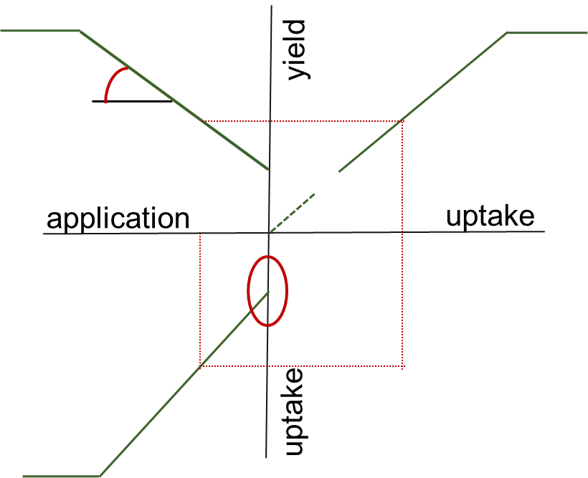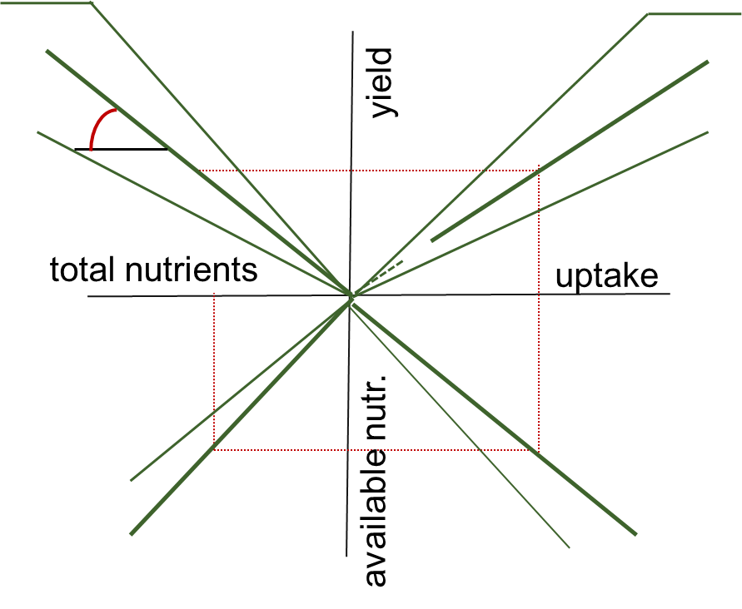

Figure #. Schematic illustration of a). crop response to fertilizer nutrient application, simplified according to de Wit (1953), and b). crop response to both soil nutrients and fertilizer nutrients, simplified according to Janssen et al. (1990).

Calculated and outputted for each crop, in two stages, are the following:

N soil content
P soil content
K soil content
1N = soil release efficiency (soil supply / content)
1P = soil release efficiency (soil supply / content)
1K = soil release efficiency (soil supply / content)
1Nf = fertilizer release efficiency (fertilizer supply / content); this is normally combined with 2
1Pf = fertilizer release efficiency (fertilizer supply / content) ; this is normally combined with 2
1Kf = fertilizer release efficiency (fertilizer supply / content) ; this is normally combined with 2
N supply
P supply
K supply
N supply from soil
P supply from soil
K supply from soil
N supply from fertilizer
P supply from fertilizer
K supply from fertilizer
2N = base uptake efficiency (recovery fraction of soil supply)
2P = base uptake efficiency (recovery fraction of soil supply)
2K = base uptake efficiency (recovery fraction of soil supply)
2Nf = uptake efficiency (recovery fraction of fertilizer supply)
2Pf = uptake efficiency (recovery fraction of fertilizer supply)
2Kf = uptake efficiency (recovery fraction of fertilizer supply)
N uptake
P uptake
K uptake
N uptake from soil (base uptake)
P uptake from soil (base uptake)
K uptake from soil (base uptake)
N uptake from fertilizer
P uptake from fertilizer
K uptake from fertilizer
3N = physiologic use efficiency of base uptake
3P = physiologic use efficiency of base uptake
3K = physiologic use efficiency of base uptake
3Nf = physiologic use efficiency of uptake
3Pf = physiologic use efficiency of uptake
3Kf = physiologic use efficiency of uptake
Yield unfertilized
Yield fertilized

Calculation of fertilizer recommendations (QUEFTSABC)

We added a module (B) to QUEFTS-R which calculates fertilizer recommendations on the basis of the nutrient requirements of target yields, defined as a fraction of the attainable yield data read from gridded maps, relative to the nutrient supplies by the soil, as calculated in the former paragraph by QUEFTS. The nutrient gap between these demands and supplies defines the amount of fertilizer nutrients which need to be taken up and, with predefined fertilizer nutrient uptake efficiencies (recovery fractions), the amount of fertilizer nutrients to be applied (the fertilizer recommendations).

The target yields were defined at 80% of the attainable yield for all crops throughout the area of interest. The nutrient requirements at those target yields were defined on the basis of the crop parameters a, d and r which define the physiological use efficiencies at diluted and accumulated nutrient concentrations (minimal and maximal yield over uptake efficiencies) and the residual uptake required for yield formation starting taking place. Defined was:

Nutrient requirement = (Target yield / (d – ((d – a)/3) )) + r

Note that we targeted an efficiency within the range between a and d, and not the initial highest efficiency (d), because we aimed to assess balanced N, P and K requirements. We targeted a use efficiency which was one third of the range less efficient than the highest (initial) efficiency and one sixth more efficient than the median efficiency. This efficiency corresponds more or less with the efficiency as calculated by QUEFTS, based on the corresponding uptakes and using a 2nd order equation, exceeding the median efficiency. In reality though, the efficiency at the calculated uptake (and thus the corresponding yield) can be higher as well as lower as the targeted efficiency (and targeted yield), depending on the actual circumstances such as rainfall etc., and most likely within the range as defined by the crop parameters a and d.

The recommendations calculated in module B were inputted as fertilizer rates in module C to calculate and verify the associated responses and yields. We expect the uptake efficiencies to be near to the maximally defined uptake efficiencies because of the recommendations being balanced in terms of the ratios between N, P and K.

2.3.2. Tier 2

In Tier 2, measured trial data have been made available for use. See paragraph 2.1 and 2.2 for the data, the applicability of the data and the actual use of the data.

Pre validation

The QUEFTSABC-R model used in Tier 2 is similar to that used in Tier 1 as well as the input data (soil maps and maps of attainable yield). The crop parameters were adjusted from the available fertilizer trial data where possible. Assessed from the data were the median as well as the minimum and maximum of the fertilizer nutrient uptake efficiencies (nutrient uptake when fertilized minus uptake when unfertilized relative to the fertilizer nutrient application rate) and the nutrient use efficiencies (yield relative to uptake at diluted and at accumulated concentrations). The minimum and maximum efficiencies were assessed at 2.5 and 97.5 percentiles, respectively. Moreover, the harvest indices (ratio of yield over biomass) were assessed for verification purposes.

Table #. Crop parameter settings defined for use in Tier 2 (adjusted in bold)
LUT | CROP | aN | aP | aK | dN | dP | dK | rN | rP | rK | rfNmed | rfPmed | rfKmed
7 | MilletT2 | 15 | 108 | 9 | 45 | 350 | 22 | 5 | 0.4 | 2 | 0.33 | 0.14 | 0.34
8 | SorghumT2 | 19 | 124 | 15 | 80 | 500 | 42 | 5 | 0.4 | 2 | 0.33 | 0.14 | 0.34
9 | MaizeT2 | 25 | 45.8 | 25.3 | 63.8 | 386.1 | 83.4 | 5 | 0.4 | 2 | 0.34 | 0.21 | 0.67
10 | RiceT2 | 54.9 | 132.9 | 47.3 | 127.2 | 505.9 | 153.1 | 5 | 0.4 | 2 | 0.23 | 0.13 | 0.43
11 | CassavaT2 | 53 | 305 | 46 | 132 | 585 | 181 | 5 | 0.4 | 2 | 0.35 | 0.13 | 0.32

Table #. Additional crop parameter settings defined for use in Tier 2 (adjusted in bold)
LUT | CROP | HI | ytargetratio | ypot | rfNmax | rfPmax | rfKmax | rfNmin | rfPmin | rfKmin
7 | MilletT2 | 0.2 | 0.8 | 6000 | 0.51 | 0.2 | 0.46 | 0.22 | 0.09 | 0.25
8 | SorghumT2 | 0.25 | 0.8 | 11000 | 0.51 | 0.2 | 0.46 | 0.22 | 0.09 | 0.25
9 | MaizeT2 | 0.38 | 0.8 | 14000 | 1.17 | 1.36 | 2.68 | -0.14 | -0.34 | -0.71
10 | RiceT2 | 0.4 | 0.8 | 13000 | 0.69 | 0.42 | 1.05 | 0.09 | -0.43 | 0.02
11 | CassavaT2 | 0.35 | 0.8 | 15000 | 0.50 | 0.19 | 0.49 | 0.22 | 0.06 | 0.22

With these settings, QUEFTSABC-R was applied to the trial point data to calculate the response to the fertilizer treatments as well as to calculate fertilizer recommendations at those point locations. The calculations are given in columns next to the corresponding measurements of response and the reported recommendations. Subsequently, QUEFTSABC-R was applied to the gridded maps to calculate and map fertilizer recommendations and the corresponding crop responses. The maps are validated at the same point locations (thus using the same data).

Post validation

Following the validation meeting with the STC in June 2017, few changes were made before doing a final assessment. First, few rules in QUEFTSABC-R were adjusted.

- The pH dependent correction factor which applies to calculating the availability (supply) of the soil nutrients was for P also applied for calculating the availability (supply) of fertilizer P. This implies that more fertilizer P is required at more acid soils to achieve a similar P uptake.
- The attainable yield data for cassava were multiplied by 2.5 to model fresh weight crop.
- The parameter defining the yield potential (ypot), maximizing the yield calculations, was lowered importantly for all crops. Herewith, diminishing returns (efficiencies) are calculated at lower uptake rates.
- Instead of using the yield potential parameter for maximizing the yield calculations, the attainable yield data, read from maps, were used to maximize yield calculations.
- The crop parameter defining the median fertilizer nutrient recovery fraction (uptake efficiency), used for the calculations, was adjusted to increase the uptake efficiency (because of balanced rates of N, P, K). We changed the parameter from the measured value at the 50 percentile (the median value) to the 60 percentile. For those crops lacking measured data on nutrient uptake, we changed the parameter from the default median to the median + 10% of the range between the minimal and maximal values. The impact of this change is that less fertilizer nutrients are recommended.
- The fertilizer recommendations are calculated for newly defined, lower, target yields at similar physiological use efficiency (d – ((d – a)/3) ). These target yield levels were derived from the maximum target yields defined during the validation by the STC. Those maxima seemed very high and near to the attainable yield levels (while it was proposed to lower the target yields) and therefore it was decided to assess the nutrient requirements at those maximum target yields at the initial highest use efficiency (d) thus at fully diluted nutrient concentrations. Those nutrient requirements were subsequently translated to lower target yield levels at the usual, lower, use efficiencies thus at more accumulated concentrations and similar uptake. Applying these recommendations will ,in ‘normal conditions’, most likely result in a yield near to the conservative target yield but will, in ‘favorable conditions’, result in a yield near to the target yield as defined by the STC and near to, but not beyond, the attainable yield level. The crop parameters, defining the ratio of target yield relative to attainable yield, were adjusted accordingly. Table # indicates the maximum values given on the GAEZ maps for attainable yield, the only slightly lower initial target yields as suggested by the STC (a realistic target at diluted nutrient concentrations) and the corresponding target yields (a realistic target in ‘normal’ circumstances at in-range (d-((d-a)/3)) nutrient concentrations. Fraction indicates the latter target yield as a fraction of the maximum attainable yield. The fraction for millet was adapted to 0.65.

Table #. Setting of the target yield as a fraction of the maximum value depicted on the attainable yield map and as defined based on the initial target yield suggested by the STC.

CROP |  | Max  attainable yield | Initial target  yield (at d) | Target yield  (at (d-((d-a)/3))) | fraction | adapt
MilletT2 |  | 3000 | 2500 | 1800 | 0.6 | 0.65
SorghumT2 |  | 6000 | 4500 | 3000 | 0.5
MaizeT2 |  | 7500 | 5500 | 4125 | 0.55
RiceT2 |  | 6500 | 6000 | 4550 | 0.7
CassavaT2 |  | 20000 | 16000 | 12000 | 0.6

Table #. Crop parameter settings defined validation for use in Tier 2 post-validation

LUT | CROP | aN | aP | aK | dN | dP | dK | rN | rP | rK | rfNmed | rfPmed | rfKmed
7 | MilletT2 | 15 | 108 | 9 | 45 | 350 | 22 | 5 | 0.4 | 2 | 0.33 | 0.14 | 0.34
8 | SorghumT2 | 19 | 124 | 15 | 80 | 500 | 42 | 5 | 0.4 | 2 | 0.36 | 0.15 | 0.36
9 | MaizeT2 | 25 | 45.8 | 25.3 | 63.8 | 386.1 | 83.4 | 5 | 0.4 | 2 | 0.4 | 0.26 | 0.82
10 | RiceT2 | 54.9 | 132.9 | 47.3 | 127.2 | 505.9 | 153.1 | 5 | 0.4 | 2 | 0.34 | 0.19 | 0.49
11 | CassavaT2 | 53 | 305 | 46 | 132 | 585 | 181 | 5 | 0.4 | 2 | 0.38 | 0.14 | 0.37

Table #. Additional crop parameter settings defined for use in Tier 2 post-validation
LUT | CROP | HI | ytargetratio | ypot | rfNmax | rfPmax | rfKmax | rfNmin | rfPmin | rfKmin
7 | MilletT2 | 0.2 | 0.65 | 3000 | 0.51 | 0.2 | 0.46 | 0.22 | 0.09 | 0.25
8 | SorghumT2 | 0.25 | 0.5 | 6500 | 0.51 | 0.2 | 0.46 | 0.22 | 0.09 | 0.25
9 | MaizeT2 | 0.38 | 0.55 | 8000 | 1.17 | 1.36 | 2.68 | -0.14 | -0.34 | -0.71
10 | RiceT2 | 0.4 | 0.7 | 8500 | 0.69 | 0.42 | 1.05 | 0.09 | -0.43 | 0.02
11 | CassavaT2 | 0.35 | 0.6 | 22000 | 0.50 | 0.19 | 0.49 | 0.22 | 0.06 | 0.22

With these settings, QUEFTSABC-R was applied again to first the trial point data and then the gridded maps.

2.3.3. Tier 3

Pre-validation

In Tier 3, fertilizer recommendations have been made available for use. These reported recommendations, at point locations, have been used to validate, or to compare with, the recommendations as calculated and mapped at those point locations in Tier 2.

Added to the recommendations as reported from the trials are recommendations for each of the crops as newly derived from the trials according to as described in paragraph 2.2.1.2. Both the reported and the newly derived recommendations have been modelled using machine learning (Random Forests; # reference) and stacks of spatial covariate maps. Annex # gives an overview of the covariates prepared and used for this purpose. Added to these covariates are the gridded output maps of Tier 2 including the recommendations as calculated using QUEFTS. We expect these Tier 2 maps to be relevant ‘enhanced’ covariates for the modelling. Modelling by Random Forests implies a large number of rounds wherein a portion of the data, which changes every round, is included in the building of the model and the other portion of the data is set aside for independent validation of the model built in each round, to the point that a best-fit model, predicting with highest accuracy, is identified together with the associated covariates. This model is applied onto the associated covariates, which are available for the entire area of interest (Ecowas region) to predict (extrapolate) the recommendations over the area.

The resulting maps of extrapolated fertilizer recommendations (those which were newly assessed for all five crops) were inputted to QUEFTS again to calculate the corresponding yield when fertilized accordingly.

Post-validation

The gridded maps produced in Tier 2 using QUEFTS, post-validation thus with latest settings, have been newly added to the covariates to newly model and extrapolate the point based fertilizer recommendations using machine learning.

2.4 Define generic crop- and site-specific fertilizer recommendations

2.5 Discuss and validate findings with regional experts (STC)

2.6 Report about the findings of the proof of concept project including data, methods, results and conclusions

2.7 Propose a pragmatic mechanism for collecting, sharing and processing of data required for all crops, AEZ’s and countries targeted for further upscaling to the whole West African

2.8 Training

3. Results

The results are available at the ISRIC ftp server (ftp://ftp.isric.org/) and are password protected. Login as ifdc with IFDCWAIFDCWA as password.

3.1. Compile fertilizer recommendations to be extrapolated

The compilation of fertilizer recommendations, and the underlying fertilizer trial data, became available for further use in the second half of March 2017. The FeRWAM (GIS map of agroecological zones & tables of fertilizer recommendations) has not been made available except for a table of draft FeRWAM data which was made available after this study (June 2017). This draft FeRWAM table compiles mainly qualitative information from various countries about fertilizer recommendations for a number of crops in a number of country-defined agro-ecological zones and is still incomplete.

3.1.1. Compile georeferenced site and crop-specific fertilizer recommendations (at xy-point locations) and related fertilizer trial data, as made readily available by IFDC (activity 1 & deliverable)

The compilation of fertilizer trial data, and fertilizer recommendations, as compiled under a common standard data, is available at the ftp server. See Figure # for an illustration of part (two trials) of the compilation. Included are separate tables (tabs) for all data of all crops together, for the data per crop, for the data sources (lineage) and for a dictionary explaining the column headings used in the tables.

All trials report measured yield data, with the majority of the trials including control yields (at 0 kg NPK/ha), and the majority of trials also reports measured straw data. Only few trials for only maize and rice also report nutrient contents measured from the crop tissues (yieldable organs and straw). The columns with yControl, yResponse, yRec and yMx have been calculated à posteriori to underpin the evaluation of the trials and the recommendations derived and represent, for each repetition, the control yield when unfertilized, the yield response relative to that control yield, the measured yield corresponding with the reported fertilizer recommendation and the maximum yield measured in the repetition.

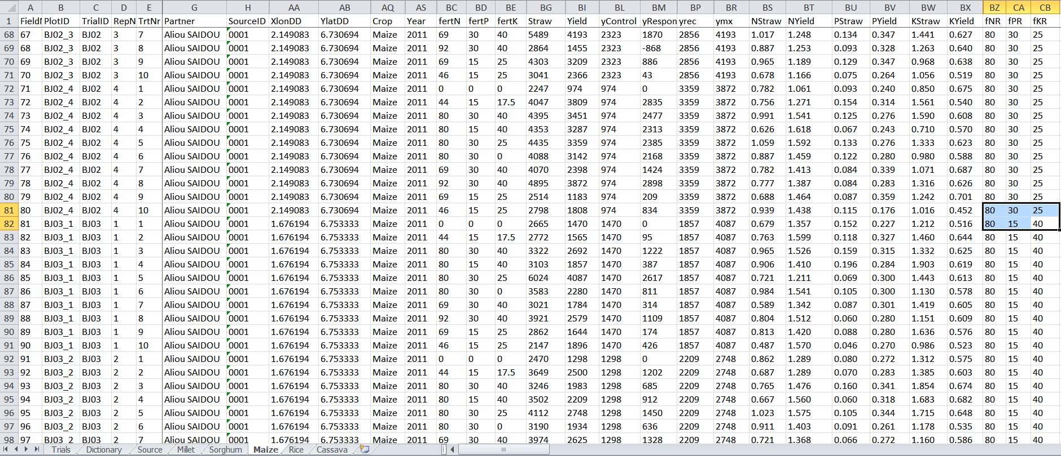
Figure #. Illustration of part of the fertilizer trial data, and fertilizer recommendations (the 3 columns at the right hand side), compiled under a common standard

The total number of trials varied according to the crop and was somewhat limited except for maize. Also the spatial distribution of the trials was limited to only narrow ranges of environmentally variable conditions with the trials for each crop located in few agro-ecological zones only (see Figure # and Figures # a, b, c, d, e).

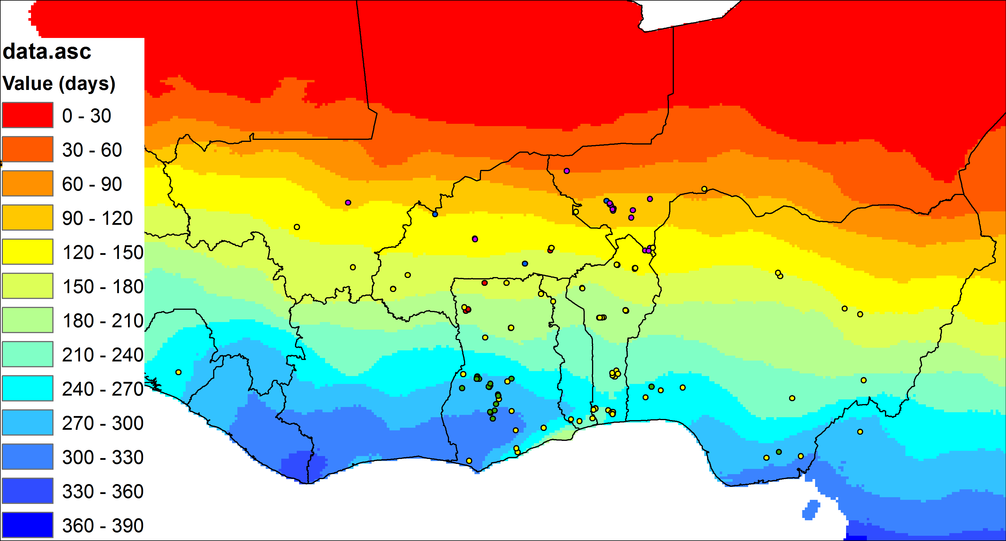
Figure #. Overview of the fertilizer trial data and their locations (dots) within the various countries and agro-ecological zones (zones of length of growing period in days). The colors of the dots indicate the different crops.

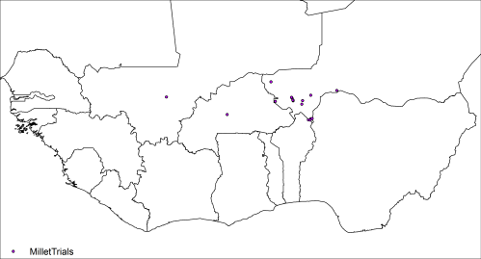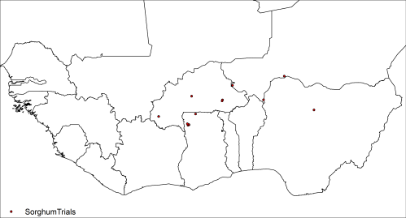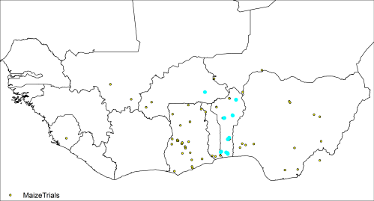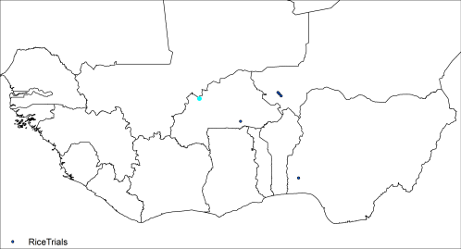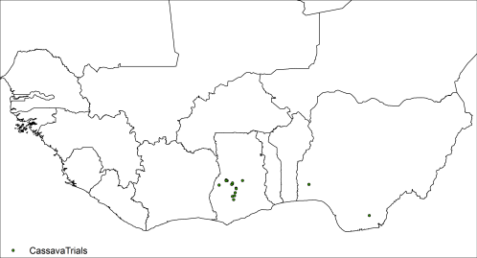
Figure # a. millet, b. sorghum, c. maize, d. rice and e. cassava. Overview per crop of the fertilizer trials and their locations The selected dots (in blue) indicate trials with available data on measured crop nutrient contents.

The nature of the trials was quite variable, as is summarized in Table #. Summed for each crop is the number of trials compiled and made available by IFDC and compiled from OFRA data, the number of records (trials, repetitions and treatments), the number of trials including an explicit fertilizer recommendation, the number of reported recommendations, the number of trials with crop analytical data (nutrient contents), the number of different years of experimentation, the number of varieties considered, the number of different management regimes reported, the number of ways to report yields (dry matter of fresh matter), the number of agro-ecological zones covered by the trials (with the zones defined on national basis) and the number of countries where the trials have been conducted.

Table #. Summary of the nature of the compiled fertilizer trial data
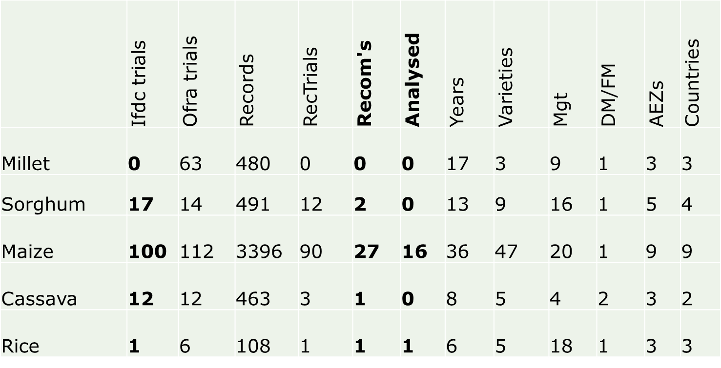

3.1.2. Review applicability of the compiled fertilizer recommendations and related fertilizer trial data (activity 1B)

The applicability of the trial data (Tier 2) and especially of the recommendations (Tier 3) proved somewhat limited due to the heterogeneous nature of the data and the recommendations as well as due to the limited quantities, limited spatial distribution and incompleteness of the data. Required for modelling, and extrapolation, are sufficient and complete data which are spatially well distributed covering the environmentally variable conditions over which the extrapolation needs to take place.

- Parameterization of the QUEFTS model (Tier 2); crop parameters have been adjusted and used in Tier 2 for those crops with available measured data on crop nutrient contents (maize and rice). Those data were unavailable for millet, sorghum and cassava and those parameters have not been adjusted.
- Modelling of the measured data using QUEFTS (Tier 2); crop yields in response to the fertilizer treatments have been calculated and compared with the measured data for each of the crops and for each of the trials including all fertilizer treatments. Also calculated but not supported by measured trial data were the underlying relationships including soil and fertilizer nutrient availability, soil and fertilizer nutrient uptake, and yield response to nutrient uptake.
- Modelling of the measured data using machine learning (Tier 2); measured crop yields have been modelled and extrapolated using machine learning, separately for the measured control yields, the measured maximum yields and the measured yields at the newly derived fertilizer recommendation rates.
- Modelling of the recommendations using QUEFTS (Tier 3); this proved not possible in a uniform manner for all crops and all trials. However, the parameter settings in Tier 2 (defining target yield and uptake efficiency) were fine-tuned such as to aim for calculating recommendations within the reported orders of magnitude.
- Modelling of the recommendations using machine learning (Tier 3); recommendations were reported for sorghum, maize, rice and cassava, not for millet. Note though that machine learning requires so called big data while the number of recommendations (number of data points as well as the number of different recommendations) was extremely limited for each of these crops. Nevertheless, the recommendations have been modelled for solely proof of concept purposes.
  - The spatial distribution of the trial-based recommendations is too narrow to support extrapolation by machine learning
  - The quantity of the trial-based recommendations is too small to support extrapolation by machine learning
  - The interpretative basis and nature of the trial-based recommendations is too heterogeneous to support extrapolation by machine learning
  - The nature of the trials is too heterogeneous to support the formulation of trial-based recommendations
- Validation of the modelled results (of Tier 1, 2 & 3); all model results were validated as far as the available data permitted and the errors quantified.

3.1.2.1. Evaluate the fertilizer recommendations, based on the fertilizer trials data (at xy-point locations and incl. soil data) as made readily available by IFDC (activity 2); Tier 3

The fertilizer recommendations formulated and reported based on the fertilizer trial data could not be reproduced in a consistent manner using the trial data. The consultants from each of the three countries applied a different basis each, based on different considerations, to do the interpretation and especially to formulate the recommendations. None of the consultants provided an explicitly worked out example of the approach applied, nor associated literature. This made the reported recommendations basically unsuitable for being used as a reference for modelling, unsuitable for being used to validate model outcomes and unsuitable for being extrapolated.

Generally, the recommendations do not show clear relationships with the measured trial data. More specifically, when considering trials one by one, clear relationships could be found for a number of trials. Note though that such analysis is out of scope of this study. Moreover, it is out of scope to interpret the trial data to the extent of formulating recommendations.

As a general impression, and not specifically referring to each or one of the crops, the recommendations as reported seem very invariable hardly showing any site-specificity. Also, the recommendations seem generally low for reaching target yields as communicated (not reported) but quite high for smallholder farmers to adopt and may prove to be financially inefficient. The recommendations include K whereas the trials hardly show response to K.

3.1.2.2. Fine-tune the evaluation and crop parameterization, for modelling, together with IFDC agronomist (activity 3); Tier 3 & 2

See Tier 2 for the crop parameterisation. The newly produced fertilizer recommendations, uniformly based on the highest agronomic fertilizer use efficiencies measured in the trials, are available at the ftp server. Generally, these recommendations are lower than those reported.

3.1.2.3. Model the fertilizer recommendations, based on the fertilizer trials data (at xy point locations), using QUEFTS and attainable target yield data, and validate results (activity 4); Tier 3 & 2

The results are available at the ftp server. The fertilizer recommendations as calculated using QUEFTS do not coincide with the recommendations as reported from the trials. The reason could be incorrect modelling with possibly inadequate assumptions and/or incoherent reporting.

Figure # illustrates the yields as modelled and calculated for millet in response to the fertilizer treatments relative to the yields as measured for millet in the fertilizer trials. Combining all data, for all trials of all years etc., results in an apparent poor relationship between modelled and measured results, hiding the relationships possibly valid for individual trials.

Figure # shows maize crop response to fertilizer treatments, as modelled and measured, only considering two selected trials (for maize). The modelled crop responses are within the ranges of the measured crop responses to N, P and K. The recommendations for N and P as modelled for the target yield at the trial locations are twice the recommendations as reported for the trials with the target yield also being twice the measured yield reported with the recommendation. The linearity suggests that the measurements as well as the reported recommendations are modelled rather well and that fine-tuning of the model parameter settings (for defining target yield) will result in an adequate model fit. The recommendation for K as modelled differs very much from the recommendation for K as reported. Calculations suggest no response to K fertilizers which is confirmed by the measurements also showing no response. The reported recommendation though is 25 to 40 kg K/ha.

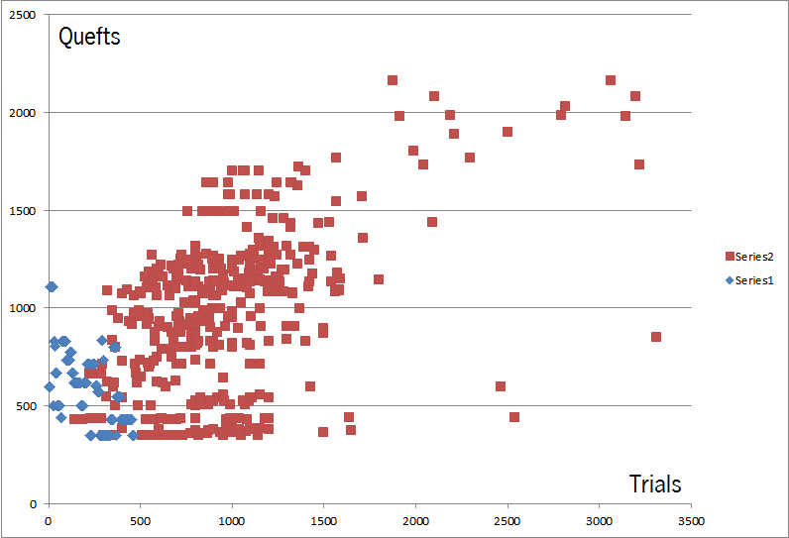
Figure #. Modelled yields (QUEFTS) relative to measured yields (Trials), for millet in both unfertilized (series 1; blue dots) and fertilized conditions (series 2; red dots), at trial point locations

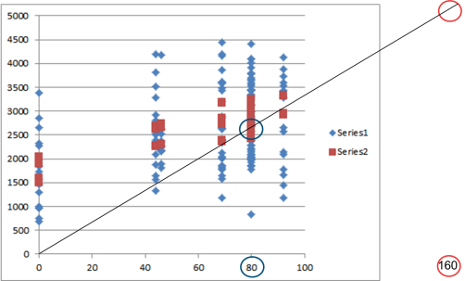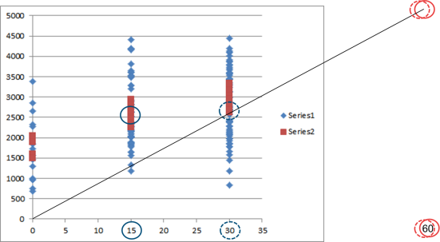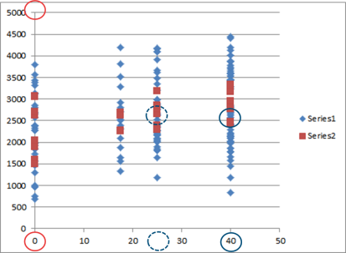
Figure # a, b, c. Maize yield (Y axis; in kg/ha) as measured (series 1; blue dots) and modelled (series 2; red dots) in two selected trials in response to a). fertilizer N, b). fertilizer P and c). fertilizer K (x-axis; in kg/ha). The blue circles indicate the recommended fertilizer rate and the associated yield as reported and the red circles as calculated (in Tier 2, pre-validation). The line indicates the linearity between the reported and the calculated recommendations, and yields, for N and P.

3.2. Produce extrapolated covariate maps required to extrapolate fertilizer recommendations, including attainable yield and yield gap estimates, crop variety and management parameters, weather and soil including QUEFTS variables (pH, organic carbon, exchangeable K and available P) and rootable depth (Activity 5 & deliverable)

3.2.1. Yield and yield gap estimates

The maps of yield estimates extrapolated using machine learning are available at the ftp server as well as the derived maps of yield gap estimates. Also given are quantitative validation results and an overview of the relative significances per model of the various covariates.

3.3. Extrapolate fertilizer recommendations and validate extrapolation results (activity 6 & deliverable)

3.3.1. Tier 1

The QUEFTS model has been implemented in R as QUEFTSABC-R as illustrated in Figure #.

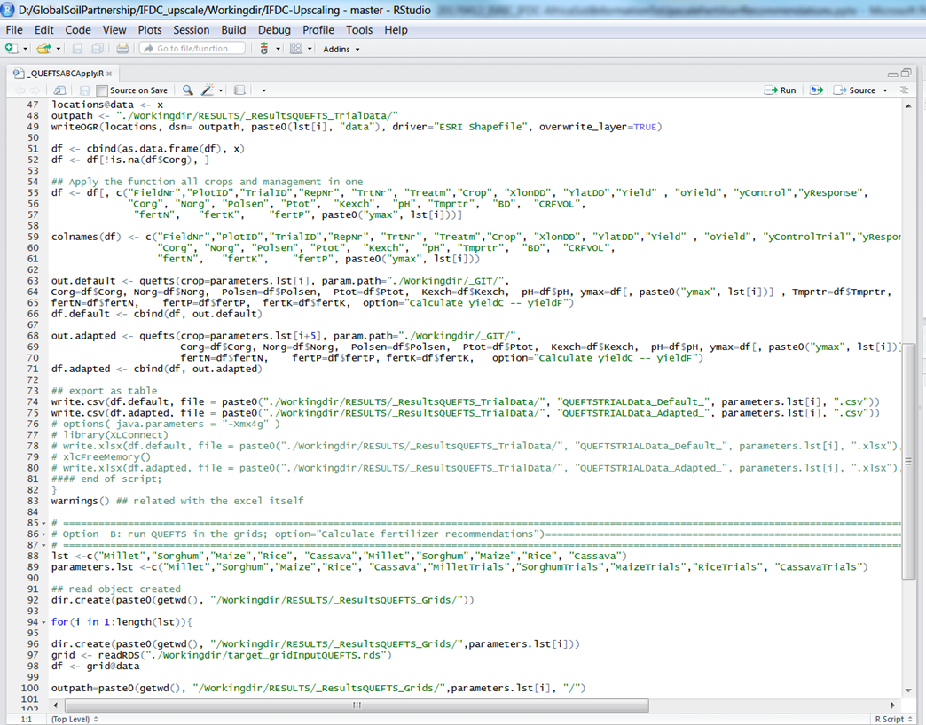
Figure #. Illustration of part of the implemented QUEFTSABC-R model

The implementation was tested as illustrated in Figure # where yields calculated using QUEFTSABC-R were compared with the yields calculated using QUEFTS earlier implemented in Fortran for a scenario stretching from the Sahara to the coast. The degree of fit is near perfect, showing that the implementation was correct, but not fully similar apparently due to a minor difference in the parameter settings.
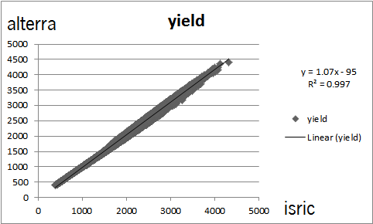
Figure #. Yields calculated by ISRIC using QUEFTSABC-R compared with the yields calculated by Alterra using QUEFTS –Fortran

3.3.2. Tier 2

The harvest index could be adjusted based on the trial data for each of the crops. The other crop parameters (nutrient uptake efficiencies [min, median, max] and nutrient use efficiencies [when diluted and when accumulated]) could be adjusted for only maize and rice. Data for the other crops were lacking. Table # shows the adjustments made for maize and rice, based on the trial data. Note the enormous decrease, from Tier 1 to Tier 2, of the P use efficiency of maize (aP and dP) and to a lesser extent for rice (dP). The physiological N and K use efficiencies remain near similar for maize and importantly improve for rice. The P and also K recovery fractions though improve for maize as well as rice both

The fertilizer P requirements, and thus the fertilizer P recommendations, in Tier 2 will be very high for maize relative to those for the other crops due to the relatively low P use efficiency.

Table #. Crop parameters for maize and rice adjusted from Tier 1 to Tier 2.
 | CROP | aN | aP | aK | dN | dP | dK | rfNmed | rfPmed | rfKmed
 | ( MaizeDefault | 30 | 200 | 30 | 70 | 600 | 120 | 0.5 | 0.1 | 0.5 )
 | MaizeT1 | 24 | 130 | 27.7 | 70 | 600 | 86 | 0.34 | 0.13 | 0.33
 | MaizeT2 | 25 | 45.8 | 25.3 | 63.8 | 386 | 83.4 | 0.34 | 0.21 | 0.67
 | RiceT1 | 36 | 155 | 18 | 80 | 850 | 86 | 0.4 | 0.1 | 0.28
 | RiceT2 | 54.9 | 133 | 47.3 | 127 | 506 | 153 | 0.23 | 0.13 | 0.43

Preceding the modelling of the measured yield responses to fertilizer nutrients, and the associated fertilizer recommendations, as was visualized in Figure #, we modelled the nutrient uptake in response to the fertiliser nutrient applications (the fertilizer treatments) using QUEFTSABC-R and the adjusted crop parameters. Figure # visualises the results (fertilizer nutrient uptake efficiencies) for two selected trials for maize. The measured uptake efficiencies

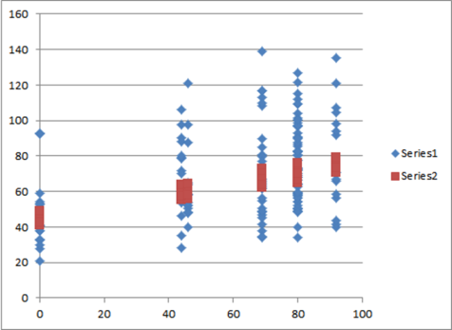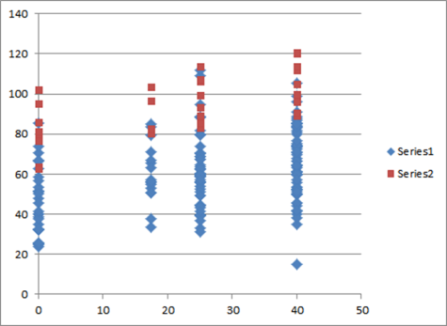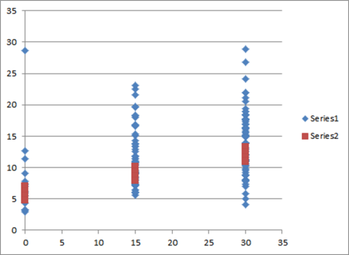
Figure # a, b, c. Nutrient uptake by maize (Y axis; in kg/ha) in response to a). fertilizer N, b). fertilizer P and c). fertilizer K (x-axis; in kg/ha) as measured (series 1; blue dots) and modelled (series 2; red dots) in two selected trials; visualising the fertilizer nutrient uptake efficiencies.

The measured effect of the nutrient uptakes on yield (physiological nutrient use efficiencies) was modelled using the adjusted parameters. The results for two selected trials for maize are visualised in Figure #. Modelled use efficiencies are for N and P relatively high compared to the measurements and for K relatively low.

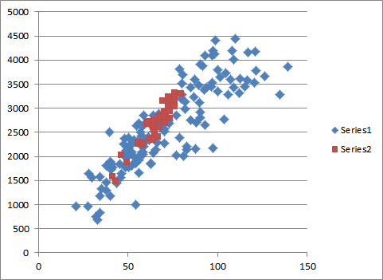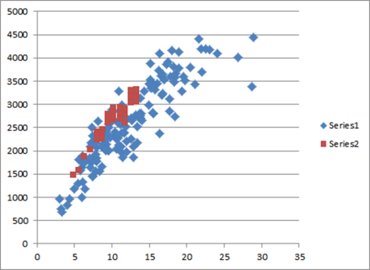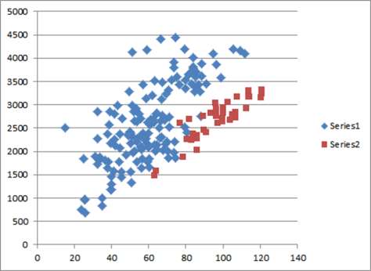
Figure # a, b, c. Yield of maize (Y axis; in kg/ha) in response to a). N uptake, b). P uptake and c). K uptake (x-axis; in kg/ha) as measured (series 1; blue dots) and modelled (series 2; red dots) for two selected trials; visualising the physiologic nutrient use efficiencies for all fertilizer treatments.

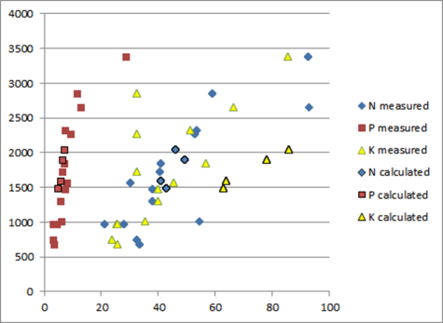
Figure #. Control yield of maize (Y axis; in kg/ha) in response to N base uptake (blue dots), P base uptake (red dots) and K base uptake (yellow dots) on the x-axes; in kg/ha, as measured (dots) and modelled (outlined dots) for two selected trials; visualising the physiologic nutrient use efficiencies when unfertilized.

3.3.3. Tier 3

4. Discussion and conclusions

Acknowledgements

Acknowledgements are due to the West Africa Fertilizer Program of USAID which is implemented by IFDC and which made this study possible.

References

AfSIS

de Pater J.,

de Wit C., 1953.

Ezui K.S., A. Mando, B. Ahiabor, F. Tetteh, J. Sogbedji, A. Tamelokpo, K. Giller, L. Franke, B. Janssen, 2012. Calibrating QUEFTS model for Improved Fertilizer Use Efficiency in Cassava based Farming System in West Africa. Symposium Agro-Environ 2012.

FAO

Fisher GAEZ

GYGA

Hengl T., J.G.B. Leenaars, K.D. Shepherd, M.G. Walsh, G.B.M. Heuvelink, Tekalign Mamo, Helina Tilahun, E. Berkhout, M. Cooper, E. Fegraus, I. Wheeler, Nketia A. Kwabena, submitted (2017). Soil nutrient maps of Sub-Saharan Africa: assessment of soil nutrient content at 250 m spatial resolution using machine learning. Nutrient cycling in agro-ecosystems.

Hengl T., G.B.M. Heuvelink, B. Kempen, J.G.B. Leenaars, M.G. Walsh, K. Shepherd, A. Sila, R.A. MacMillan, J. Mendes de Jesus, L. Tamene, J.E. Tondoh, 2015. Mapping soil properties of Africa at 250 m resolution: random forests significantly improve current predictions. PLoS One 10(6). DOI: 10.1371/journal.pone.0125814.

Iowa State University

Guilpart

Janssen B.H., F.C.T. Guiking, D. van der Eijk, E.M.A. Smaling, J. Wolf and H. van Reuler, 1990. A system for Quantitative Evaluation of the Fertility of Tropical Soils (QUEFTS). Geoderma 46, 299-318. Elsevier.

Janssen B.H. and F.C.T. Guiking, 1990. Modelling the response of crop to fertilizers. In: L.M. van Beusichem (ed.), 1990. Plant nutrition – physiology and application, 699-703. Kluwer Academic Publishers.

Janssen B.H., 2010. Simple models and concepts as tools for the study of sustained soil productivity in long-term experiments. II. Crop nutrient equivalents, balanced supplies of available nutrients, and NPK triangles. Plant Soil, DOI 10.1007/s11104-010-0590-0. Springer.

Leenaars J.G.B., T. Hengl, M. Ruiperez Gonzalez, J. Mendes de Jesus, G.M.B. Heuvelink, J. Wolf, L. van Bussel, L. Claessens, H. Yang and K.G. Cassman, 2015. Root zone plant-available water holding capacity of the Sub-Saharan Africa soil, version 1.0. Gridded functional soil information (dataset RZ-PAWHC SSA v. 1.0). ISRIC report 2015/02. Collaboration project of Africa Soil Information Service (AfSIS) and Global Yield Gap and Water Productivity Atlas (GYGA). ISRIC - World Soil Information, Wageningen

Sattari S.Z., M.K. van Ittersum, A.F. Bouwman, A.L. Smit and B.H. Janssen, 2014. Crop yield response to soil fertility and N, P, K inputs in different environments: Testing and improving the QUEFTS model. Field Crops Research 157, 35-46. Elsevier.

Annexes
Annex 1. Terms of Reference

No. | Terms of Reference | Activity | Deliverable
1 | Compile georeferenced site and crop-specific fertilizer recommendations (at xy-point locations), as made readily available by IFDC, and review applicability  > Site specific data (fertilizer recommendations at point locations and related fertilizer trials) as made readily available by IFDC compiled and applicability reviewed | Y | Y
2 | Evaluate the fertilizer recommendations, based on the fertilizer trials data (at xy-point locations and incl. soil data) as made readily available by IFDC | Y | -
3 | Fine-tune the evaluation (2) and crop parameterization, for modeling, together with IFDC agronomist | Y | -
4 | Model the fertilizer recommendations based on the fertilizer trials data (at xy point locations), using QUEFTS and attainable target yield data, and validate results | Y | -
5 | Produce extrapolated covariate maps required to extrapolate fertilizer recommendations, including attainable yield and yield gap estimates, crop variety and management parameters, weather and soil including QUEFTS variables (pH, organic carbon, exchangeable K and available P) and rootable depth.  > Maps of yield gap, where possible, and of soil pH, organic C, exchangeable K, available P for the pilot countries (to be used as covariates for extrapolation) | Y | Y
6 | Extrapolate fertilizer recommendations and validate extrapolation results  > Fertilizer recommendations for the pilot countries extrapolated, and extrapolation results validated; | Y | Y
7 | Define generic crop and site-specific fertilizer recommendations  > Generic crop and site specific fertilizer recommendations defined for Benin, Ghana and Burkina, validated and mapped; | Y | Y
8 | Discuss and validate findings with regional experts (includes 5 days of international travel expert)  > Meeting with regional experts in West Africa to discuss findings of the extrapolation exercise; | Y | Y
9 | Report about the findings of the proof of concept project including data, methods, results and conclusions  > Report on proof of concept findings for fertilizer recommendation extrapolation, including data, methods, results and conclusions; | Y | Y
10 | Propose a pragmatic mechanism for collecting, sharing and processing of data required for all crops, AEZ’s and countries targeted for upscaling recommendation to the whole West African Region  > Mechanism proposed for collecting, sharing and processing of data required for upscaling recommendations to different crops, agroecological zones and target countries. | Y | Y

# Fertilizer recommendations need to be spatially interpolated over the ECOWAS AoI. This will results in crop- and site-specific recommendations in terms of kg/ha of N, P and K for maize, sorghum, rice (irrigated) and millet and possibly also cassava. Note, I’ve insisted several times to specify the basis of the recommendations which though so far has not been adequately followed up. Basis could be: a) NPK gift required to attain target yield, b) NPK gift resulting in the highest NPK efficiency, of N, of P or of K, c) NPK gift resulting in the highest value to cost ratio, or simply the highest net value. Options b and c are least reliably assessed consistently and least easily extrapolated. For option c, the costs and the values should be defined similarly over the AoI. Option d) also considers the temporary variation determining the risk, or likeliness, of response to NPK.

# Data on the recommendations, including geolocation, are not yet available from IFDC and are expected earliest half February which complicates adequate planning. Similarly, fertilizer trials data are not yet available. Please note also that the exact nature of the data which will be provided is still unknown. A template has been provided and partners have started preparing the data. It is already clear that the data will not be complete (e.g. no NPK contents) and will in cases not represent individual plots (trial-treatment-repetition) but a higher level of aggregation (e.g. the plots of a treatment or even, for e.g. soil data, the full trial). Coordinates are generally lacking and gps readings are being taken in the field (despite my recommendation to geo reference from a reliable map as e.g. google earth).

# Therefor we’ll apply Tiers. Quefts will be used to produce Tier 1 results which serve as a backup for the deliverables as well as a covariate for the interpolations. Irrespective of the availability of the IFDC data, we can already prepare the spatial QUEFTS functionality, including scripts, input data and input/output interface, parameterization and model adaptation. For this purpose we have a draft version in R available. We will compare the results, of test runs with default settings for a test area, with results generated by WER to validate our script. For this we will provide WER with the grid derived input data (ascii), parameters settings and specify which version of the formulae is used.

# The interpolations (of GYGA point data) require adequate covariates, including inputs for Quefts and outputs of Quefts, which can be prepared already.

# The interpolations in Tier 2 of fertilizer trial point data and recommendation point data require same covariates. Plus point data. I’ll study the OFRA fertiliser trials point data to possibly use as alternative data or add to the ifdc data.

# The donor project ends in May and this project should be completed April 18th. The main results should be presentable at a forum workshop organized by IFDC 11-13 April.

Objectives
Define crop- and site-specific NPK fertilizer recommendations for the Ecowas region; pilot project to produce maps of NPK recommendations for pilot crops (maize, sorghum, pearl millet and irrigated wetland rice and possibly cassava) covering pilot countries (Benin, Burkina Faso and Ghana).

Workplan

TIER 1
Get R-Quefts operational and tested; DONE
- Study Quefts literature and R-Quefts script
- Adjust R-Quefts to meet project specific goals (expand R-QUEFTS with simple top-up model to R-QUEFTSABC to calculate control yield (A), NPK fertiliser recommendations from target yield (B) and fertilised yield (C) whereby fertiliser rate is either as calculated in B or as externally defined)
- Define R-Queftsabc input data, parameters and output data
- Verify input data conversion-factors
- Prepare gridded maps of input data for AoI (see annex) including conversions
- Define test area and prepare input data for sharing with WER (gridded input data including pixel ID converted to ascii files)
- Prepare parameters, including defaults
- Get R-Queftsabc running for test area with prepared input data and parameters
- Verify test results
- Verify script, including formulae, and fine tune further towards project specific goals (to facilitate both default and adjusted runs)
- Define scenario for second test (both default plus recommendations), do second test and compare results with WER results
- Evaluate comparison and possibly correct errors
- Reset formulae and parameters for project purposes (attention to rf definition)

Produce yield gap maps by interpolation (LOWER PRIORITY; we’ll do this later)
- Prepare GYGA point data (see annex) of crop specific YW, YW-sd and YA.
- Prepare covariates of AoI (see annex)
- Prepare extrapolation model
- Newly produce gridded maps of max yields (YW) and actual yields (YA) by interpolation of GYGA points. Produce yield gap maps (YW minus YA)
- Multiply YW and YA maps with LGP-based AEZ factors (0-1), and possibly merge (average) results of YW (and of YW-sd) with GAEZ-intermed grids and of YA with GAEZ-low grids, after first having looked at the interpolation results, and produce yield gap maps (YW aez minus YA aez)

Collect and compile fertilizer trial point data. DONE
- Prepare and share template for consultants to compile data under a common standard
- Monitor and guide compilation; put emphasis on the need for timely results, explicit recommendations on a common basis and georeferencing (of individual plots or aggregated plots)
- In the meanwhile study and add other available fertiliser trial data (OFRA, CIAT Ag-Trials). DONE
- Arrange and understand compiled data

Run R-QueftsABC on trial data for 5 crops using default parameters and settings. => TO DO
- Run R-QUEFTSabc for point locations. Read soil data and ymax from grids, and fertiliser application rates from table (different fertN, fertP, fertK rates per location), produce tabled results for all output variables added to the input table (same field ID)
- Compare calculated yields with measured yields (fertilised and control yields), calculated recommendations (fNR, fPR, fKR) with measured (derived) recommendations (fNR, fPR, fKR, fNRec, fPRec, fKRec) and calculated NPK fertiliser efficiencies with measured efficiencies (NfertUE, PfertUE, KfertUE)

Run R-QueftsABC on gridded data for AoI and 5 crops as Tier 1 deliverable => TO DO
- Use GAEZ-intermed maps as ymax
- Produce tabled R-Quefts results for all output variables and gridded results for yControl, yFertilised, fNR, fPR, fKR, NfertUE, PfertUE, KfertUE.
- Validate calculated fNR, fPR, fKR with measured trial data on fNR, fPR, fKR (from consultants) and fNRec, fPRec, fKRec (from highest efficiencies).

TIER 2
Adjust parameters. DONE
- Interpret trial data and derive crop parameters from measurements (a, d, HI, rfNmed, rfPmed, rfKmed) and derive, for each trial, yield levels (yControl000, ymx000, fRyld), recommendations based on efficiencies (fNRec, fPRec, fKRec) and efficiencies (recNfertUE, recPfertUE, recKfertUE). DONE.
- Adjust crop LandUse parameters based on above interpretation (MilletTrials, etc). DONE

Run R-QueftsABC on trial data for 5 crops using adjusted parameters and default ymax settings. => TO DO
- Run R-QUEFTSabc for point locations again. Read soil data and ymax from grids, and fertiliser application rates from table (different fertN, fertP, fertK rates per location), produce tabled results for all output variables added to the input table (same field ID)
- Compare calculated yields with measured yields (fertilised and control yields), calculated recommendations (fNR, fPR, fKR) with measured (derived) recommendations (fNR, fPR, fKR, fNRec, fPRec, fKRec) and calculated NPK fertiliser efficiencies with measured efficiencies (NfertUE, PfertUE, KfertUE)

Run R-QueftsABC on gridded data for AoI and 5 crops as Tier 2 default deliverable. => TO DO
- Use GAEZ-intermed maps as ymax
- Produce tabled R-Quefts results for all output variables and gridded results for yControl, yFertilised, fNR, fPR, fKR, NfertUE, PfertUE, KfertUE.
- Validate calculated fNR, fPR, fKR with measured trial data on fNR, fPR, fKR (from consultants) and fNRec, fPRec, fKRec (from highest efficiencies), with RMSE, R2 etc. and XY graphs.

Interpolate trial data to adjust ymax settings for QueftsABC and for yield gap => TO DO
- Prepare point data (ymx000 and fRyld and also ycontrol000)
- Prepare covariates (see annex and earlier discussions)
- Prepare extrapolation model
- Produce gridded maps ymax and yrec and also ycontrol (calculate yield gap (GAEZ minus ycontrol) = deliverable)
- Validate

Run R-QueftsABC on gridded data for AoI and 5 crops as Tier 2b deliverables, using adjusted parameters and settings => LOWER PRIORITY; WE’LL DO THIS LATER WHEN TIME PERMITS
- Use interpolated map of ymx000 as ymax for QueftsABC and assess fNR, fPR and fKR recommended to meet target yield derived from ymax
- Produce tabled R-Quefts results for all output variables and gridded results for yControl, yFertilised, fNR, fPR, fKR, NfertUE, PfertUE, KfertUE.
- Validate calculated fNR, fPR, fKR with measured trial data on fNR, fPR, fKR (from consultants) and fNRec, fPRec, fKRec (from highest efficiencies), with RMSE, R2 etc. and XY graphs.

- Use interpolated map of fRyld (yrec) as ymax for QueftsABC to assess fNR, fPR and fKR recommended to meet target yield derived from fRyld (at ytargetratio = 1.0) at highest efficiencies
- Produce tabled R-Quefts results for all output variables and gridded results for yControl, yFertilised, fNR, fPR, fKR, NfertUE, PfertUE, KfertUE.
- Validate calculated fNR, fPR, fKR with measured trial data on fNR, fPR, fKR (from consultants) and fNRec, fPRec, fKRec (from highest efficiencies), with RMSE, R2 etc. and XY graphs.

TIER 3
Produce interpolated maps from trial data of key deliverables (fNR, fPR, fKR) => TO DO important
- Prepare point data (fNRec, fPRec, fKRec); note that point data for fNR, fPR, fKR are too few to use.
- Prepare covariates (see annex and earlier discussions)
- Add to covariates: newly produced grids of yield gap
- Add to covariates: gridded Quefts outputs (of tier2) of fNR, fPR, fKR, yFertilised
- Prepare extrapolation model
- Produce gridded maps of fNRec, fPRec, fKRec
- Validate with measured (derived) recommendations

Run R-QueftsABC on gridded data for AoI and 5 crops as Tier 3 deliverable => TO DO
- Use map of GAEZ as ymax for QueftsABC
- Use interpolated map of fNRec, fPRec, fKRec of as input of fertN, fertP, fertK (reach target efficiencies)
- Produce tabled R-Quefts results for all output variables and gridded results for yControl, yFertilised, fNR, fPR, fKR, NfertUE, PfertUE, KfertUE.
- Validate yControl, yFertilised, fNR, fPR, fKR, NfertUE, PfertUE, KfertUE with measured trial data on yControl000, fRyld, fNRec, fPRec, fKRec, recNfertUE, recPfertUE, recKfertUE with RMSE, R2 etc. and XY graphs.

- For sorghum, for a situation (tier 2 or tier 3) to be decided, produce tiffs for all Quefts output variables => TO DO

Translate maps into generic maps. LOWER PRIORITY
- Produce AEZ’s (zones) based on LGP (steps of 30 days; < 60, 60-90, 90-120,..)
- Generalise recommendations to averages per AEZ

Ready for use 31 March

LATER
Validate with regional experts & present at regional forum
- Prepare data
- Prepare presentation
- Present
- Discuss and identify issues to be improved and updated

Propose a data sharing mechanism
- Propose a data sharing mechanism for future ECOWAS partners concerning fertiliser trial data & recommendations

Compile final results
- Resolve issues and update results
- Prepare accessible data
- Prepare report

First draft incl. specific details:
1. Introduction

2. Materials and methods
Summary first steps
-Prepare gridded maps (serving as input data to quefts and as covariates for interpolation), listed below
-Get quefts running with gridded input data

-Newly produce gridded maps of target yields by interpolating GYGA points merged with GAEZ grids (serving as input data to quefts and as covariates for interpolation)
-Expand R-QUEFTS model with simple model to calculate recommendations from target yields

-Check conversions input data, define parameters
-Produce gridded output of adapted QUEFTS and to the covariates

> to do.
>> to do soon.
>>> to do first.

2.1. Input data
Used as input data, for the production of interpolated, AoI-wide, maps of fertilizer nutrient recommendations (kg/ha of N, P and K) and associated yields, were point based fertilizer recommendations formulated from measured NPK fertilizer trial data of IFDC.
Used as input data, for the production of interpolated maps of attainable and actual crop yields, were point based model results of GYGA.

MassiveStorage/IFDC_upscale /InputData/PointData/IFDC_measuredCropYields_points/
- Will follow
- These data (yield, straw, N content, P content, K content) will be used to adjust QUEFTS parameters and to validate QUEFTS at point locations

MassiveStorage/IFDC_upscale /InputData/PointData /GYGA_simulatedCropYields_points/
IFDC_GygaRainfedMaizeWAfr.xlsx tab Stations, columns YA, YW, YW-YA, YW_CV_Temporal, YA_CV_Temporal
IFDC_GygaRainfedMilletWAfr.xlsx tab Stations, columns YA, YW, YW-YA, YW_CV_Temporal, YA_CV_Temporal
IFDC_GygaRainfedSorghumWAfr.xlsx tab Stations, columns YA, YW, YW-YA, YW_CV_Temporal, YA_CV_Temporal
IFDC_GygaIrrigatedRiceWAfr.xlsx tab Stations, columns YA, YW, YW-YA, YW_CV_Temporal, YA_CV_Temporal
YA = actual yield (kg/ha), YW = water-limited yield, YW-YA = yield gap, CV = coefficient of multiannual variation

- Missing: cassave
- We interpolate YA, YW, YW-sd, YW-YA
- The interpolated yields will be merged with the GAEZ yield maps to define target yields for QUEFTS
- We use YW_CV_Temporal to interpolate TW-sd.

Used as input data, for the production of spatial covariates which are needed for the interpolation and which are calculated using QUEFTS, were gridded maps available from IIASA of crop yields attainable under different management regimes (low, medium, high), as assessed for the Global AEZ project (Fischer et al., 2012), and gridded AFGyga soil property maps (SoilGrids) available from ISRIC for organic C and total N, available P and total P, exchangeable K and pH-H2O (Hengl et al., 2015 and 2017).

>>> >>> Prepare below maps (input data), all for the AoI, projected in LAEA and 1km resolution
> > Convert values according to the targeted units and targeted properties (can also be done during the calculations in the R script)

MassiveStorage/IFDC_upscale/AoI/AoI_ECOWAS.shp

MassiveStorage/IFDC_upscale /InputData/GridData/Soil/ From Af Nutrients maps.
N_M_agg30cm_AF_1km.tif , total N in ppm, ok
P_M_agg30cm_AF_1km.tif , available P-m3 in pp100m (divide by 100 for ppm), ok
K_M_agg30cm_AF_1km.tif , K-m3 in ppm, ok
OC_agg30cm_AF_1km.tif , org. C in g/kg, ok
P.T_M_agg30cm_AF_1km.tif , total P ppm, ok
>>> >>> Add: pHH2O_M_ agg30cm_AF_1km.tif and divide by 10 [AfSoilgrids or WorldSoilGrids? -> Af] . This is derived from the Africa Soil Grids.
> (> Add: possibly: soil temperature) Added as mean(day temperature avg, night temperature avg)

>> >> Convert P-m3 in pp100m to P.O (P-olsen) in ppm (can also be done in QUEFTS script). Done when QUEFTS is applied.
P.O (ppm) = 2.36 + 0.37 * [P-m3 / 100], mixed effect model (Job).
>>> >>> This equation needs verification.
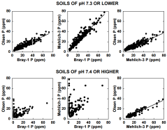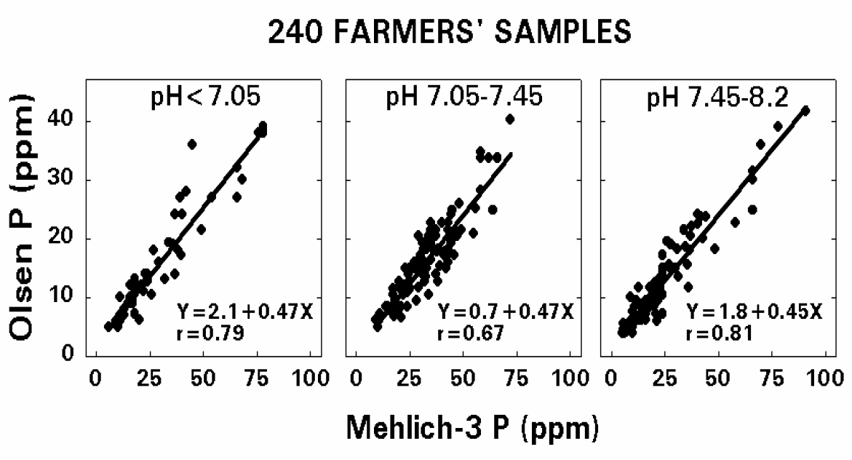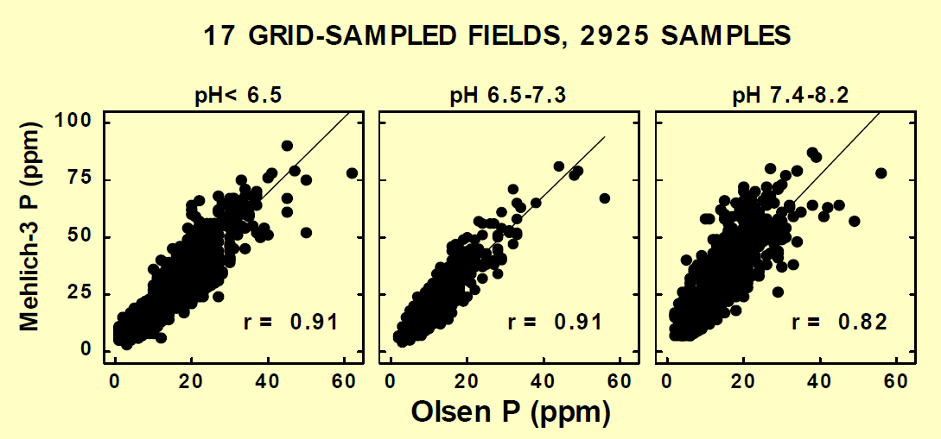
Source: Iowa State University.
If pH < 7.05
P.O (ppm) = 2.1 + 0.47 * P-m3 (ppm)
If 7.05 < pH < 7.45
P.O (ppm) = 0.7 + 0.47 * P-m3 (ppm)
If pH > 7.45
P.O (ppm) = 1.8 + 0.45 * P-m3 (ppm)
Simplified:
P.O (ppm) = 1.5 + 0.46 * P-m3 (ppm)

>> >> Convert K-m3 in ppm to K-m3 in cmolc/kg (divide by 390). This can also be done in QUEFTS script.
(Job’s QUEFTS script is in mmolc/kg; thus divide K-m3 by 39).
Instead; convert K-m3 in ppm to K-exchangeable (NH4Ac) in mmolc/kg by (Job):
K-exch (mmolc/kg) = 26.43 + 0.986 * K-m3 (ppm).
>>> >>> This equation needs verification (seems incorrect)
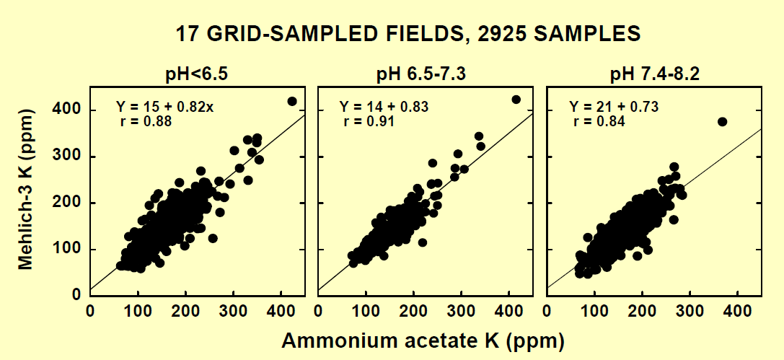
If pH < 7.3
K-exch (ppm) = [K-m3 (ppm) – 14.5] / 0.825
K-exch (mmolc/kg) = [[K-m3 (ppm) – 14.5] / 0.825] / 39 = [K-m3 (ppm) – 14.5] / 32.2
= -0.45 + 0.031 * K-m3
If pH > 7.3
K-exch (ppm) = [K-m3 (ppm) – 21] / 0.73
K-exch (mmolc/kg) = [[K-m3 (ppm) – 21] / 0.73] / 39 = [K-m3 (ppm) – 21] / 28.5
= -0.738 + 0.035 * K-m3

> > Verify if OC map is in g/kg (checked; is okay).
>> >> Note, these soil maps are aggregated to 30 cm while QUEFTS assumes 20 cm. Consider if worthwhile to use the original predictions at 250m and re-aggregate over 20 cm? Or assess a correction factor from profile data?

- We calculate absolute soil contents of N, P, K (kg/ha) from relative contents (ppm) in soil over 30 cm depth. Ok.

MassiveStorage/IFDC_upscale /InputData/GridData/Soil/To_KgPerHa/
BLDFIE_M_agg30cm_AF_1km.tif , bulk density fine earth in kg/m3, from GYGA project
CRFVOL_M_agg30cm_AF_1km.tif , volumetric coarse fragments in v%,

- We calculate effective absolute soil contents of N, P, K (kg/ha) from relative contents (ppm) in effective soil over 30 cm depth

MassiveStorage/IFDC_upscale/InputData/GridData/GAEZ_attainableYields/ > crop specific grids
Cassave_rainfed_intermed_baseline/data.asc & data.prj, done
Maize_rainfed_intermed_baseline/data.asc & data.prj, done
Millet_rainfed_intermed_baseline/data.asc & data.prj, done
Rice_irrigated_intermed_baseline/data.asc & data.prj, done
Sorghum_rainfed_intermed_baseline/data.asc & data.prj, done

> > All files are named data.asc (with data.prj) for all crops and management regimes. (Give specific names).

MassiveStorage/IFDC_upscale/InputData/NewlyProduced_targetYields/ , empty
>> >> To be produced (see covariates)

MassiveStorage/IFDC_upscale /InputData/Parameters/QUEFTS_parameters.xlsx , empty
>> >> estimate and update crop specific QUEFTS parameters
- a, d and r parameters per crop
Defaults
Updates from Duivenbooden (1992)
Further updates from fertilizer trial data
- adapted QUEFTS
- Uptake requirement of target yield: average of a and d. Also see IPNI. (https://www.ipni.net/app/calculator/home)
- Recovery fractions
- Slightly different (see papers massive storage)
1N = soil release efficiency (soil supply / content) ; note this is normally combined with 2
1P = soil release efficiency (soil supply / content) ; note this is normally combined with 2
1K = soil release efficiency (soil supply / content) ; note this is normally combined with 2
1Nf = fertilizer release efficiency (fertilizer supply / content); this is normally combined with 2
1Pf = fertilizer release efficiency (fertilizer supply / content) ; this is normally combined with 2
1Kf = fertilizer release efficiency (fertilizer supply / content) ; this is normally combined with 2
2N = base uptake efficiency (recovery fraction of soil supply)
2P = base uptake efficiency (recovery fraction of soil supply)
2K = base uptake efficiency (recovery fraction of soil supply)
2Nf = uptake efficiency (recovery fraction of fertilizer supply)
2Pf = uptake efficiency (recovery fraction of fertilizer supply)
2Kf = uptake efficiency (recovery fraction of fertilizer supply)
3aN = physiologic efficiency at maximum dilution
3aP = physiologic efficiency at maximum dilution
3aK = physiologic efficiency at maximum dilution
3dN = physiologic efficiency at minimum dilution
3dP = physiologic efficiency at minimum dilution
3dK = physiologic efficiency at minimum dilution
Crop ratios NP, NK, PK, NPK
N harvest index
P harvest index
K harvest index
Harvest index

2.2. Covariates
2.2.1. Existing covariates
Used as spatial covariates, for the interpolation of NPK recommendations and fertilized and unfertilized yields, were below list including gridded QUEFTS outputs.

>>> >>> Prepare below maps (covariates), all for the AoI, projected in LAEA and 1km resolution

MassiveStorage/IFDC_upscale/Covariates/SHP/ , shapefiles
AfSIS_WRB.shp ok
GYGA-CZ_Ecowas_GDD_AAI_TS.shp
> Use four 3 columns (as 3 covariates);
ED_code (extrapolation domains; categorical)
GDDavg (growing degree days; semi-numerical classes); ok
AAIavg (aridity index; semi-numerical classes); ok
TSavg (temperature seasonality; semi-numerical classes);ok
MassiveStorage/IFDC_upscale/Covariates/GAEZ/ActualYields/ > crop specific grids (fragmented); 5 rasters, 1 per crop.
MassiveStorage/IFDC_upscale/Covariates/GAEZ/AttainableYields/ > crop specific grids
Cassave_rainfed_intermed_baseline/data.asc & data.prj, ok
Cassave_rainfed_high_baseline/data.asc & data.prj, ok
Maize_rainfed_intermed_baseline/data.asc & data.prj, ok
Maize_rainfed_high_baseline/data.asc & data.prj, ok
Millet_rainfed_intermed_baseline/data.asc & data.prj, ok
Millet_rainfed_high_baseline/data.asc & data.prj, ok
Rice_irrigated_intermed_baseline/data.asc & data.prj, ok
Rice_irrigated_high_baseline/data.asc & data.prj, ok
Sorghum_rainfed_intermed_baseline/data.asc & data.prj, ok
Sorghum_rainfed_high_baseline/data.asc & data.prj, ok
Cassave_rainfed_low_baseline/data.asc & data.prj, ok
Maize_rainfed_low _baseline/data.asc & data.prj, ok
Millet_rainfed_low_baseline/data.asc & data.prj, ok
Rice_irrigated_low_baseline/data.asc & data.prj, ok
Sorghum_rainfed_low_baseline/data.asc & data.prj, ok

> > All files are named data.asc (with data.prj) for all crops and management regimes. Give specific names.

MassiveStorage/IFDC_upscale/Covariates/GAEZ/AEZ/
GAEZ NPP;ok
GAEZ LGP; ok
GAEZ ET, ok
GAEZ ratio P/PET; 2 grids one PET ratio annual, ratio seasonal
MassiveStorage/IFDC_upscale/Covariates/AfricaSoilNutrientMaps/ Total: 16 grids.
MassiveStorage/IFDC_upscale/Covariates/AfricaSoilNutrientMaps/Cluster/Total:22 grids.
> > check which cluster maps to use
MassiveStorage/IFDC_upscale/Covariates/NPP_ftp_africagrids/ , htm
> > already included in covariates ? Ok.
MassiveStorage/IFDC_upscale/Covariates/add/ , empty
>> >> Add: covariates used for WordGrids 250m (more actual set)
>> >> Add: other commonly used covariates, including those also used for Namibia, ok
>> >> Add: GYGA grids

Maria, thus please,
ftp://ftp.isric.org/

ftp://ftp.isric.org/GYGA_Inputs/ : all

ftp://ftp.isric.org/GYGA_Intermediate_Results/GYGA_Intermediate_Results_ERZD/
05/12/2015 12:00 10,416,927 af_LRI_T__M_sd1_1km.tif
05/12/2015 12:00 9,949,227 af_LRI_T__M_sd2_1km.tif
05/12/2015 12:00 11,230,221 af_LRI_T__M_sd3_1km.tif

ftp://ftp.isric.org/GYGA_Results/Aggregated_over30cm/
04/10/2015 12:00 5,128,597 af_agg_30cm_AWCpF23__M_1km.tif
04/10/2015 12:00 8,433,981 af_agg_30cm_PWP__M_1km.tif
05/04/2015 12:00 58,227,744 af_agg_30cm_TAWCpF23__M_1km.tif
04/10/2015 12:00 9,208,183 af_agg_30cm_TAWCpF23mm__M_1km.tif
04/10/2015 12:00 7,841,844 af_agg_30cm_TETAs__M_1km.tif

ftp://ftp.isric.org/GYGA_Results/Aggregated_overERZD/
04/10/2015 12:00 10,656,375 af_ERZD__M_1km.tif
04/10/2015 12:00 17,085,217 af_agg_ERZD_TAWCpF23mm__M_1km.tif

I thus think to conclude not to need :
ftp://ftp.soilgrids.org/data/AF/aggregated/1km or
http://isric.org/content/african-soilgrids-250m-geotiffs :

Thanks, Johan

2.2.2. Newly produced covariates

>>> >>> Produce new covariates:
MassiveStorage/IFDC_upscale/Covariates/YieldGaps/ , empty
Target yield
> > Produce crop specific maps of the ratio of GAEZ-intermed / GAEZ-high (for maize increasing from 0.647 to 0.687 from south to north in AoI)
> > Interpolate crop specific YW data points (GYGA), using crop specific covariates including GAEZ-high, and validate
> > Produce map of the average of the interpolated YW map and the GAEZ-high map (is the water-limited yield attainable in a high management regime)
> > Multiply the average map with the ratio to calculate the target yield which is water-limited and attainable in a moderate management regime)
> > Validate the target yield map with the GAEZ-intermed map to assess possibly errors
>>> >>> This target yield map serves as covariate but also as input data to QUEFTS

Actual yield
> > Interpolate crop specific YA data points (GYGA), using crop specific covariates including GAEZ-low, and validate
> > Produce map of the average of the interpolated YA map and the GAEZ-low map (is the water-limited yield attainable in a low management regime without fertilisers =~ actual yield)
> > Validate the averaged map with the GAEZ-low map to assess possibly errors

Yield gap
>> >> Calculate yield gap map (is a deliverable)
> > Yield gap intermed = Target yield grid minus actual yield grid
> > Yield gap high = Attainable yield grid minus actual yield grid
> > Possibly, interpolate YW-YA point data (GYGA) using covariates including here produced grids

MassiveStorage/IFDC_upscale/Covariates/ GriddedQUEFTSoutputs/ , empty
>> >> To be produced

2.3. Framework

We used a tiered approach to produce maps of NPK recommendations.

2.3.1. Tier 1
In Tier 1 we use QUEFTS (and adapted simplified version) to produce gridded maps for the AoI of crop-specific NPK recommendations, calculated from gridded input data. Input data, including data on soil and target yield, and parameters are as described in section 2.1.

MassiveStorage/IFDC_upscale/QUEFTS/Python-QUEFTS_pps
Sattari et al.
MassiveStorage/IFDC_upscale/QUEFTS/R-QUEFTS_JdP
Janssen et al. (incl. few adaptations from Sattari et al. )
>>> >>> Study R-QUEFTS
>>> >>> Test R-QUEFTS functionality
>>> >>> Reproduce JdP results
>>> >>> Optimise and test inputting-outputting
>>> >>> Use gridded input data of 10*10 km of AoI
- Soil
- Target yield
>>> >>> Use tabled input data (point based)
- Soil
- Target yield
>>> >>> Use tabled parameters
>>> >>> Improve and correct conversions of input data
- P-olsen, K-exchangeable
>>> >>> Extend and improve model according to purpose
>>> >>> Script conversion of relative soil data (g/kg) to absolute soil data (kg/ha)
>>> >>> Script target yield determining NPK requirements
>>> >>> Different from QUEFTS: we use the target yield together with the average of accumulated and diluted nutrient contents (parameters a and d) to calculate crop nutrient uptake requirements (kg/ha.yr).
>>> >>> Different from QUEFTS: we use crop nutrient uptake requirements (kg/ha.yr) minus unfertilized crop uptake to calculate crop fertilizer nutrient uptake requirements (kg/ha.yr).
>>> >>> Different from QUEFTS: we use crop fertilizer nutrient uptake requirements and (tabulated) fertilizer recovery fractions to calculate crop fertilizer nutrient recommendations (kg/ha.yr)

>> >> Apply QUEFTS
>> >> Calculate absolute soil contents of N, P, K (kg/ha) from relative contents (ppm) in soil over 30 cm depth
>> >> Calculate soil supply of N, P, K (kg/ha.yr) available for uptake (which is a fraction of absolute soil content)
>> >> Calculate unfertilized crop uptake of N, P, K (kg/ha.yr) from soil supply
>> >> Calculate unfertilized (actual) crop yield (kg/ha) from unfertilized crop uptake
> > (Validate the gridded QUEFTS results)

>> >> Calculate crop nutrient uptake requirements (kg NPK /ha.yr), from target yield and (average of) accumulated and diluted nutrient contents (parameters a and d) or IPNI contents
>>> >>> Test: Quick target yield map = GAEZ-intermed maps as target yield
>> >> Test: Better target yield map = as newly produced covariate (merge from GAEZ and interpolated GYGA points)
>> >> Calculate crop fertilizer nutrient uptake requirements (kg/ha.yr), from crop nutrient uptake requirements (kg/ha.yr) minus unfertilized crop uptake
>> >> Calculate crop fertilizer nutrient recommendations (kg/ha.yr), from crop fertilizer nutrient uptake requirements and (tabulated) fertilizer recovery fractions.
>> >> (Validate the gridded QUEFTS results)

2.3.2. Tier 2
In Tier 2, fertilizer trial data are available. Those data are used to fine tune the parameterization of QUEFTS before QUEFTS is applied to the grids. The gridded outputs of QUEFTS will serve as covariate for the interpolation of the fertilizer trial data.

> > Prepare fertilizer trial data
Prepare point based fertilizer trial data (in progress)
Prepare and derive point based fertilizer recommendations
Validate QUEFTS at point basis and re-parameterise
> > Identify interpolation model
Random forest & gradient boost
> > Prepare covariates, see earlier section
Covariates yet prepared
Gridded QUEFTS output
Apply (re-parameterized) QUEFTS to the grids.
> > Interpolate
Unfertilized yields (use point data or fragmented grid data to interpolate)
Fertilized target yields
N recommendation
P recommendation
K recommendation

2.3.3. Tier 3

2.4. Validation
2.4.1. Validation of intermediate products
2.4.2. Validation of final products of each Tier

2.5. Propose a regional future data sharing mechanism

2.6. Prepare final results (generic advices, report, presentation, accessible data).

3. Results

Annex.

Capacity
Incomes |  |  |  | Costs (EZ)
Staff | Fee (euro) | Days | Sum (euro) | Staff | Fee (euro) | Days | Sum (euro)
JL Cat. III |  | 95 |  | JL Cat. III | 792 | 40
 |  |  |  | BK Cat. III | 792 | 10
 |  |  |  | MRG Cat. II | 632 | 40
 |  |  |  | GvL Cat. IV | 975 | 0.5
 |  |  |  | GH Cat. V | 976 (update) | 2.5
Expenses |  |  |  | Expenses |  |  | 3.500,-
 |  |  |  | Third parties |  | 15 | 15.000,-
 |  |  |  | Reserved
NET |  | 95 |  |  |  |  | 0,-

Annex 2.

\

